**Name:** Nader Mohamed Shedeed

**B.N:**979

**Course Code:**ECE006

**Topic:** Programming Languages

**GitHub link:**

**GitHub pages:**

**Tonic brief:**

I chose this topic because of its importance in the computer science. They are the languages allow you to make the computer serve you. Programming Language is the future language as it makes any machine to do what you told it. And this forms the importance of them.

**Screenshot:**

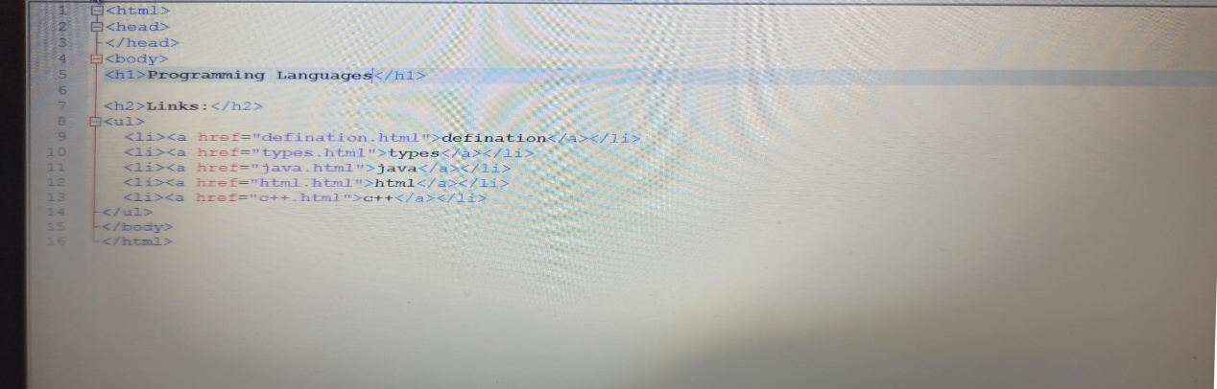Sorce code:

Other codes:

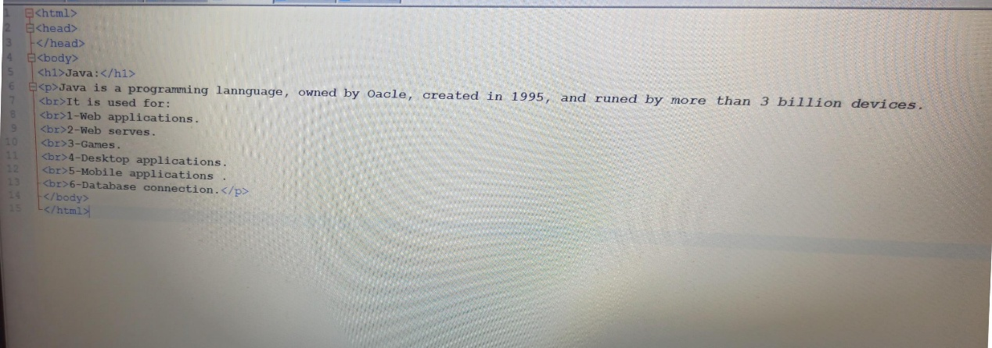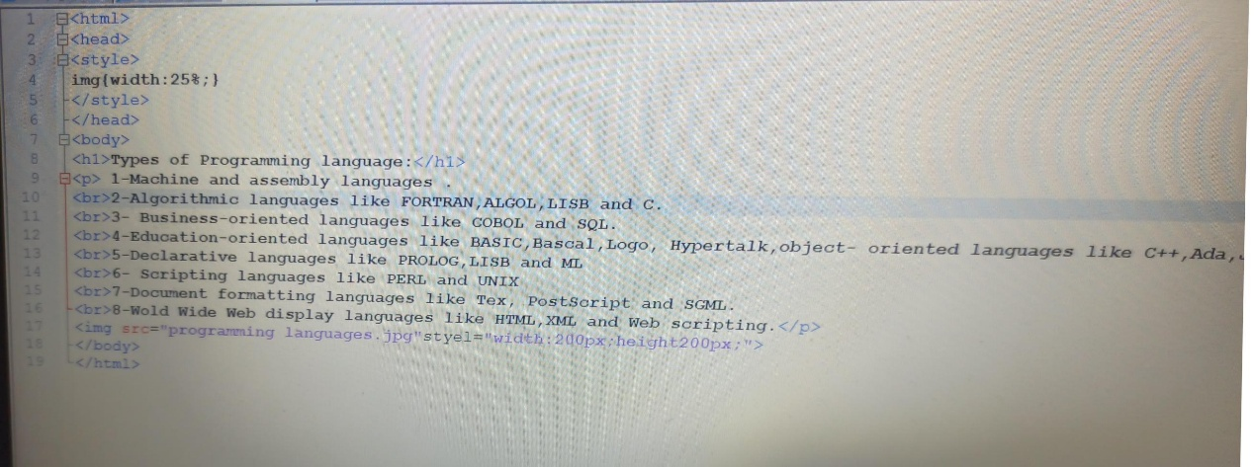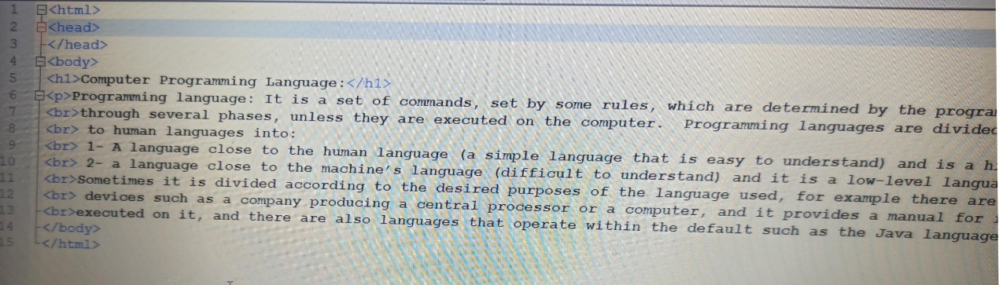

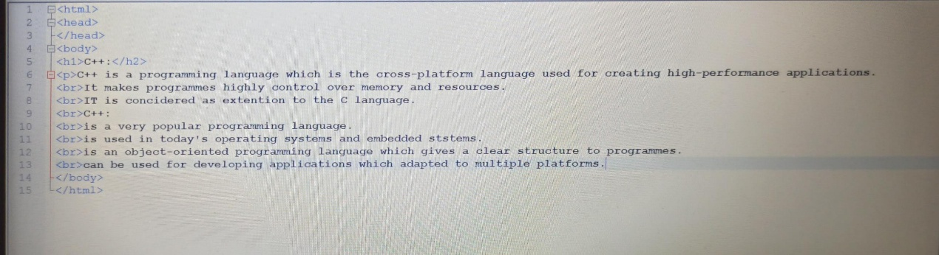

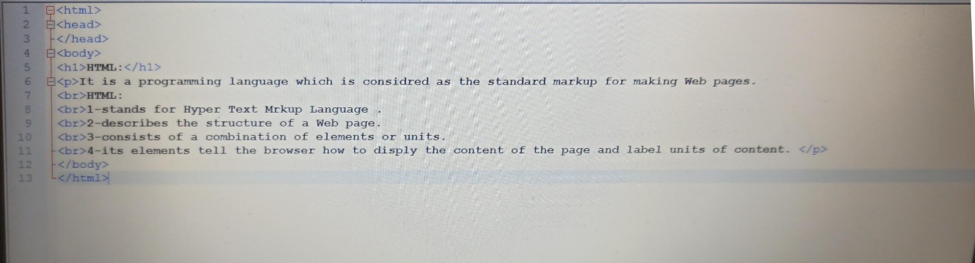

Main page:

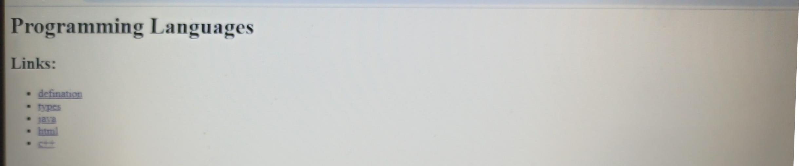

Other pages:

